Nucleic Acid Extractor—NP9032
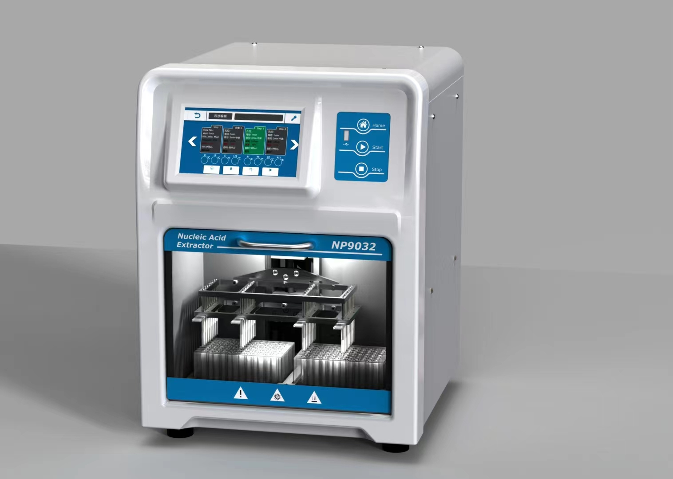
Description:
NP9032 is a device for DNA and RNA purification by using magnetic separation technology from different samples, such as whole blood, virus, tissues, cultured cells, bacteria and plant samples. The device is capable of using magnetic rods to transfer particles through the various purification phases of binding, mixing, washing and elution, offering a solution with minimized hands-on time. The DNA and RNA purification is of high quality and high molecular weight.

Features:
- 7 inch Touch screen, users can easily create and edit running programs.
- Heating function in Lysis and elution.
- Rapid extraction: 30~60min/time.
- Can process 32 samples per time
- 120 groups of programs can be stored.
- Automatic control system, no need connect to computer.
- Free programming to meet the needs of different reagent.
- High purity and excellent yield of nucleic acid.
- UV disinfection function, time range 1min~120min.
- Vibration mixing, adjustable in 3 gear: slow, middle and fast.
- Safety door design: When open the door, the program is automatically suspended. When close the door, the program can continue to run.

Parameters:
Model | NP9032
Sample volume | 20ul~1000ul
Sample throughput | 1~32
Magnetic bead recovery rate | >95%
Plate types | 96 Deep-well plate
Difference between extraction holes | CV<5%
Lysis temperature | RT.+5°C~120°C
Elution temperature | RT.+5°C~120°C
Heating time | ≤4min(from room temperature to 120°C)
Temperature accuracy | ±1°C
Operation interface | 7-inch touch screen, 3 shortcut buttons
Extension interface | USB, RS232
Program storage capacity | 120
Lighting system | Yes
Disinfection function | UV light
Exhaust way | By fan
Data storage | Available, with built-in SD card
Power | 350W
Input voltage | AC85~265V/50-60Hz
Fuse | 250V 3A Ф5×20
Dimension(mm) | 421x377x506
Weight(kg) | 24

